CS 305 Project One Template

Document Revision History

Version | Date | Author | Comments
1.0 | 01/21/26 | Thoura Chris Ouk

Client



Instructions
Submit this completed vulnerability assessment report. Replace the bracketed text with the relevant information. In this report, identify your security vulnerability findings and recommend the next steps to remedy the issues you have found.

- Respond to the five steps outlined below and include your findings.
- Respond using your own words. You may also include images or supporting materials. If you include them, make certain to insert them in the relevant locations in the document.
- Refer to the Project One Guidelines and Rubric for more detailed instructions about each section of the template.

Developer
Thoura Chris Ouk

1. Interpreting Client Needs
Determine your client’s needs and potential threats and attacks associated with the company’s application and software security requirements. Consider the following questions regarding how companies protect against external threats based on the scenario information:

- What is the value of secure communications to the company?
- Are there any international transactions that the company produces?
- Are there governmental restrictions on secure communications to consider?
- What external threats might be present now and in the immediate future?
- What modernization requirements must be considered, such as the role of open-source libraries and evolving web application technologies?

Artemis Financial develops plans involving sensitive data such as savings, retirement portfolios, investments and even insurance. The RESTful web API handles confidential information. This is crucial to making security safe for Artemis. They need to prevent breaches to ensure (or at least prevent) no sensitive information/data is lost and taken into the wrong hands. This of course can lead to financial loss, identity theft and information leaked etc.

The value of secured communications can be things such as having secure communications can be extremely critical for Artemis Financial to protect sensitive financial information in transit from interception or tampering. Without secured communication, the company can exposed sensitive financial information/data. This can lead to information going into the wrong hands and once again will put data/information, customers account etc. in jeopardy.

As far as international transactions are concerned, I don’t believe that Artemis Financial does any international transactions. There was no evidence of Artemis Financial doing anything overseas or internationally, so I would assume that the company is not international. However, it should be also reasonable to assume that a financial company would make international transactions. Financial companies usually do. We would now have to take into consideration compliance with international data transfer rules and regulations.

Some governmental restrictions on secure communications would be restrictions such as US export controls on cryptographic software, data sovereignty laws that require adequate protection for data transfers, and transactions to protect all information.

External threats found are API attacks, (specifically SQL injections) phishing, DDoS attacks and malware.

Some modernization requirements would include having the latest software requirements, browsers and servers used for the financial institute. Also, making sure all security operations are updated to the latest versions. Role of open source libraries would be to regularly scan for vulnerabilities and avoid the unmaintained ones.

2. Areas of Security

Some areas of security concern would be:

- Authentication
- Authorization
- Confidentiality
- Data integrity
- Auditing

Authorization would include things such as authenticating users. Authorization would mean making sure the right personnel uses the correct programs/applications that pertain to them and their job title. Confidentiality would include things such as protecting sensitive financial information. Encryption in transit/storage. This is critical for compliance and trust.

Refer to the vulnerability assessment process flow diagram. Identify which areas of security apply to Artemis Financials software application. Justify your reasoning for why each area is relevant to the software application.

After looking at the report, I believe that the area of security that applies to Artemis Financial would be the following:

- Input Validation
- Secure API Interactions
- Cryptography
- Client/Server
- Code Error
- Code Quality
- Encapsulation

Input validation means things such as the user input such as login credentials, financial details, plan parameters and search queries etc. Without strong validation, it is vulnerable to injection attacks such is SQL injection.

Secure API interactions. Insecure APIs risk unauthorized access, data leakage, injection via API endpoints and broken level authorization.

Cryptography can mean things such as storage of sensitive financial data. Encryption must protect data in transit. Weak or missing cryptography could lead to breaches.

Client/Server would be addressing secure composition in distributed systems, including session management, secure cookies, CORS policies, and preventing man in the middle attacks.

Code error: improper error handling can lead to leaking internal details to attackers, aiding future exploits on the attackers’ part.

Code Quality means if the code is bad due to poor quality, that can lead to increased attacks. We can fix that by having better coding. Code quality can mean bad things for the company if quality of code is compromised. The company’s application uses open-source libraries and follows patterns for controllers, services, data access, etc. Poor code quality, like coded secrets, insecure deserialization, lack of least-privilege principles, or outdated patterns can all lead to increases of the attack surface.

Encapsulation hides internal data representations, this prevents unauthorized access or manipulation of sensitive structures via reflection, deserialization attacks or just plain errors. Strong encapsulation enforces data integrity and access boundaries.

3. Manual Review
Continue working through the vulnerability assessment process flow diagram. Identify all vulnerabilities in the code base by manually inspecting the code

While manually inspecting the code, I have come up with these vulnerabilities:

- Input validation
- APIs
- Cryptography
- Client/Server
- Code Error handling
- Code quality
- Encapsulation

Input validation shows that it has no user input. None was accepted or processed in the code.
With no controllers or endpoints defined, we see that the code has an API issue. The code also has no encryption logic or configuration. There is also no communication handling on the part of the client/server. The spring boot code generally handles startup errors generically, at least that’s what I heard. So, this code does not seem to have the correct code error handling. The code quality is also suspect, with no hard-coded secrets, or unsafe patterns. Encapsulation also means that the code has nothing to encapsulate improperly.

4. Static Testing
Run a dependency check on Artemis Financial’s software application to identify all security vulnerabilities in the code. Record the output from the dependency-check report. Include the following items:

- The names or vulnerability codes of the known vulnerabilities
- A brief description and recommended solutions provided by the dependency-check report
- Any attribution that documents how this vulnerability has been identified or documented previously

Using the Maven dependency-check plugin, I analyzed the codebase. Below are the known vulnerabilities from the report, grouped by dependency. Copying and pasting the results gave me this:

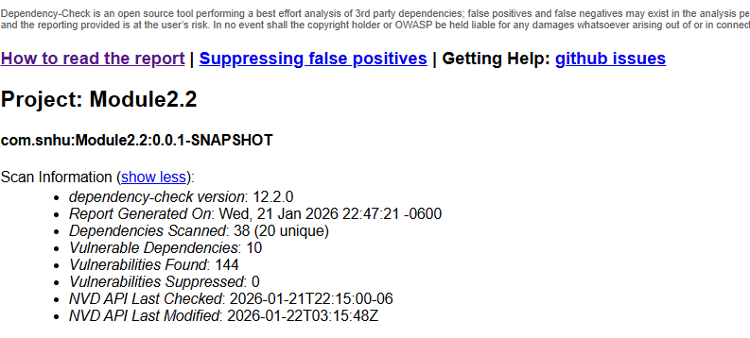

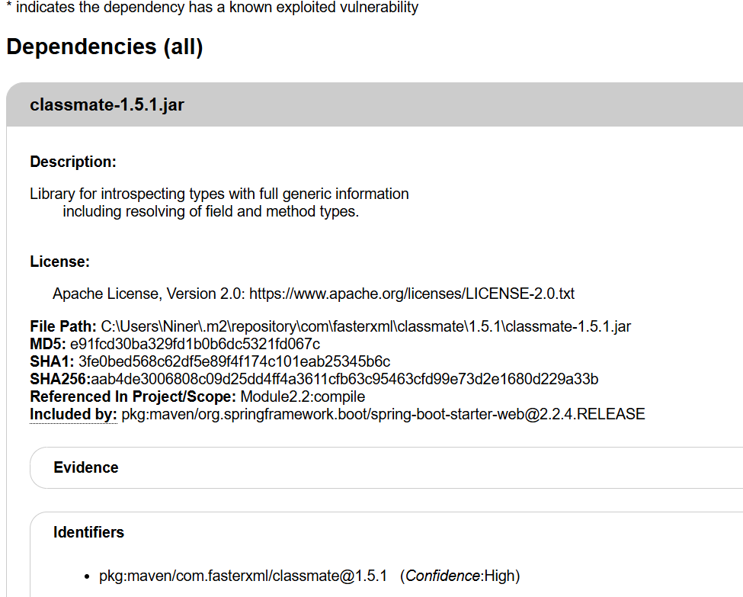

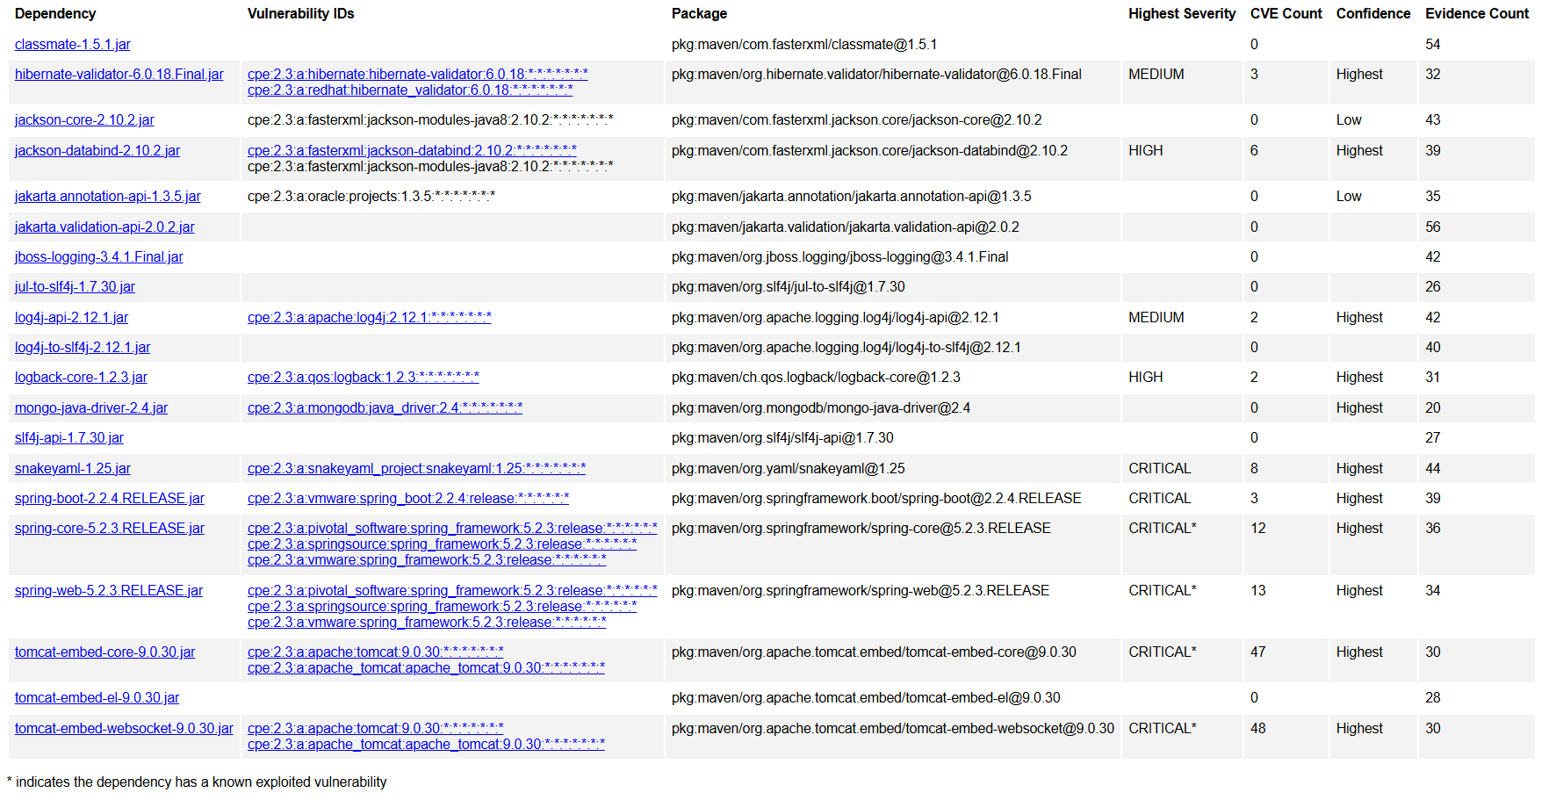

5. Mitigation Plan
Interpret the results from the manual review and static testing report. Then identify the steps to mitigate the identified security vulnerabilities for Artemis Financial’s software application.

As far as the mitigation plan goes, I think Artemis Financials software application, based on the vulnerability assessment process, would tell me to identify the security vulnerabilities. The plan should mitigate risks by taking care of the seven areas of vulnerability. Input validation, APIs, cryptography, client/server, code error handling, code quality, and encapsulation.

- Input validation: validate all user inputs using some kind of reliable validation framework
- APIs, implement authentication and authorization to ensure more security.
- Cryptography issues would mean that I would need to ensure that all data transmitted between the client and server is encrypted using TLS (Transport Layer Security) this will protect against things like eavesdropping and man in the middle attacks. Regularly updating the latest versions would also help a lot. Data encryption is part of this process also. This is done by ensuring all data received from the client is validated and sanitized to prevent any kind of injection attacks.
- Client/Server can deal with something similar as cryptography issues. This involves a systematic approach to enhance security across the architecture. We can do things such as implementing secure communication protocols, strengthen authentication mechanisms, enhance data encryption, secure key management, input validation and security measures.
- Fixing code error handling can involve just doing the right code and implementing it correctly to begin with. That is not always logical or feasible though. We can do things such as use structured exception handling, write unit tests to ensure that error handling works as expected in different scenarios. Test the entire client server flow to validate that error handling is effective across the architecture.
- Code quality deals with establishing code standards. We can mitigate it by using define style guides, implement version control, conduct code reviews, write automated tests, and refractor regularly.
- To manage encapsulation, we can make sure to ensure that the internal states of objects are protected from unintended interference and misuse. We can do this by using access modifiers, encapsulate data in classes, implement getters and setters, and design with interfaces.

